**R Bridge - Week 1 Assignment**

Please place your solution in a single file in your GitHub repository, and provide the URL in your assignment link.

1. Write a loop that calculates 12-factorial.

inPvec<-1 #predefine vector to concatenate results into

for (x in 1:12){

# browser()

if(x == 1) inPvec <- 1

else {

inPvec <- inPvec * x

}

cat(x, "!:", inPvec, "\n")

}

Output:

1 !: 1

2 !: 2

3 !: 6

4 !: 24

5 !: 120

6 !: 720

7 !: 5040

8 !: 40320

9 !: 362880

10 !: 3628800

11 !: 39916800

12 !: 479001600

Resource: <http://stackoverflow.com/questions/18375370/return-value-from-function-when-iterating-in-a-loop-r>

1. Show how to create a numeric vector that contains the sequence from 20 to 50 by 5.

> nVec <- seq(20, 50, by = 5)

> is.vector(nVec, mode = "numeric")

[1] TRUE

1. Show how to take a trio of input numbers a, b, and c and implement the quadratic equation.

Using r to solve the below quadratic equation: 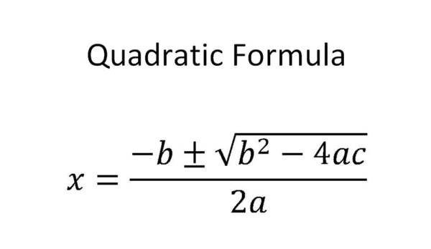

QFun <- function(a, b, c) {

numSqrt <- b^2 - 4*a*c

if(numSqrt > 0) {

x1 <- (-b+sqrt(b^2 - 4*a*c))/(2*a)

x2 <- (-b-sqrt(b^2 - 4*a*c))/(2*a)

x <- c(x1, x2)

x

} else if (numSqrt == 0) {

x <- -b/(2*a)

x

} else {"No results when the number under square root less than 0."}

}

#Test with x^2−2*x+1=0

> QFun(1, -2, 1)

[1] 1

Image resource: https://tothereal.wordpress.com/2013/05/06/why-is-it-that-students-always-seem-to-understand-but-then-never-remember/